**EEE361**

**ASSIGNMENT**

**SET-6**

1. An expression for an electric field is given below

$E=20Cos\left(ωt-2x-3z\right)$ ay V/m

Is incident on a dielectric slab (Z ≥ 0) 5.5With µr = 1.0 and εr = 2.5 Find:

1. The polarization of the wave
2. The angle of incidence
3. The reflected E and H field
4. The transmitted E and H field

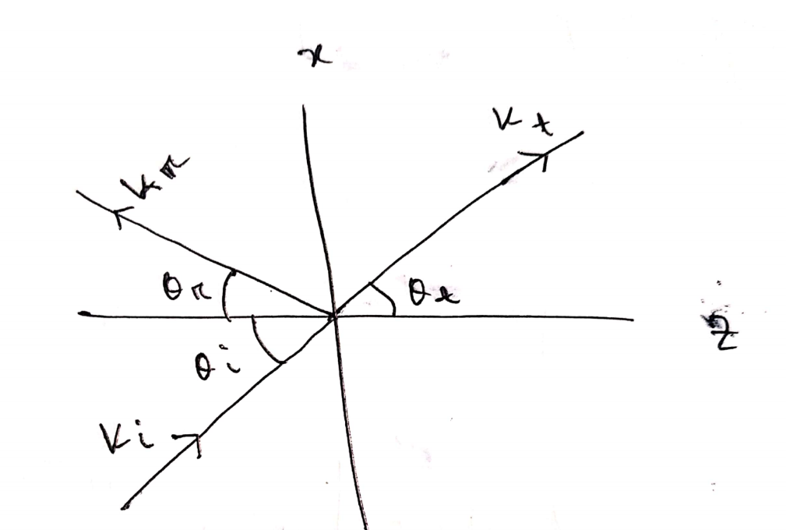

Fig: Problem 1

1. Suppose **E** fields and **H** fields are:

$$E = E_{0}e^{j\left(k.r-⍵t\right)}$$

$$H= H_{0}e^{j\left(k.r-⍵t\right)}$$

$Where$ k = kxax + kyay + kzaz and r = xax+yay+zaz

Show that $∇ × E = - ∂B/∂t$ can be expressed as K $×$ E = $μωH$ and deduce ak aE = aH

For the same fields:

Show that Maxwell’s equation in a source-free region can be written as

k.E = 0

k.h=0

k $×$ E = $μωH$

k $×$ H = $- μωH$

From these equations deduce ak aE = aH and ak aH = aE

1. a. let ${F }_{1}={ x }^{2}\hat{z}$ and ${F }_{2}= x\hat{x} + y\hat{y} + z\hat{z}$ calculate the divergence and curl of F1 and F2. Which one can be written as the gradient of a scalar? Find a scalar potential that does the job.

Which one can be written as the curl of a vector? Find a suitable vector potential.

b. Show that ${F }_{3}= yz\hat{x} + zx\hat{y} + xy\hat{z}$ can be written both as the gradient of a scalar and as the curl of a vector. Find scalar and vector potentials for this function.

1. For time varying fields: Find which if the following equations are not satisfy Maxwell’s Equation. Also state why the expression/s don’t satisfy Maxwell’s Equation? (Show Calculation)
$∇∙J + \frac{∂ρ_{v}}{∂t} = 0$

$∇∙D = ρ_{V}$

$∇∙ E = - \frac{∂B}{∂t}$

$\oint{H∙ dl} = \int{(σE + ε\frac{∂E}{∂t}} ) ∙ dS$

$\oint{B∙dS} = 0$

2. In free space $E=20Cos\left(ωt-50x\right)$ ay V/m, Find:
3. Jd
4. H

$ω$